Report of the national team of the Republic of Kazakhstan on the ascent to the peak of Gronki (Big White) 5050m along the northwest wall, first ascent , approximately 5B category .

Responsible for preparing the report: Shchukin Grigory

Climbing passport:
- Region: Tien Shan, Western Kokshaal-Too ridge
- Summit: Gronki Peak (Big White) , 5 0 50m along the western wall, first ascent
- Supposed: 5 B kt ., first ascent
- Route type: combined
- Route characteristics:
route elevation difference : 830 m
main part elevation difference: 600 m
route length: 1390 m
length of sections 5 k.sl : 285 m (climbing 5b-6a)
length of 6 category sections : 390 m (climbing from 6a+, aid climbing)
- Left on the route: total: 1 hooks incl.
- Team running hours: 19.5 hours, 2 days
- Number of overnight stays: under route - 1
- Supervisor:
Shchukin Grigory Olegovich , I s.r.​
Participants:
Shesternin Roman Valerievich, MS
Krupa Leonid Andreevich, MS
- Team coaches:
Skopin Artem Alekseevich, MS
Ten Maxim Valentinovich, MS
Titov Vyacheslav, MS
- Route processing: 3 hours, 1 day ( July 25 )
- Departure on route: 6:00 , July 26 , 2022
- Summit: 20: 3 0, 2 July 6 , 2022
- Return to the tent under the route : 2 2:30, 2 July 6 , 2022
- Organization: Federation of Mountaineering and Rock Climbing of the Republic of Kazakhstan

General photo of the summit and the route
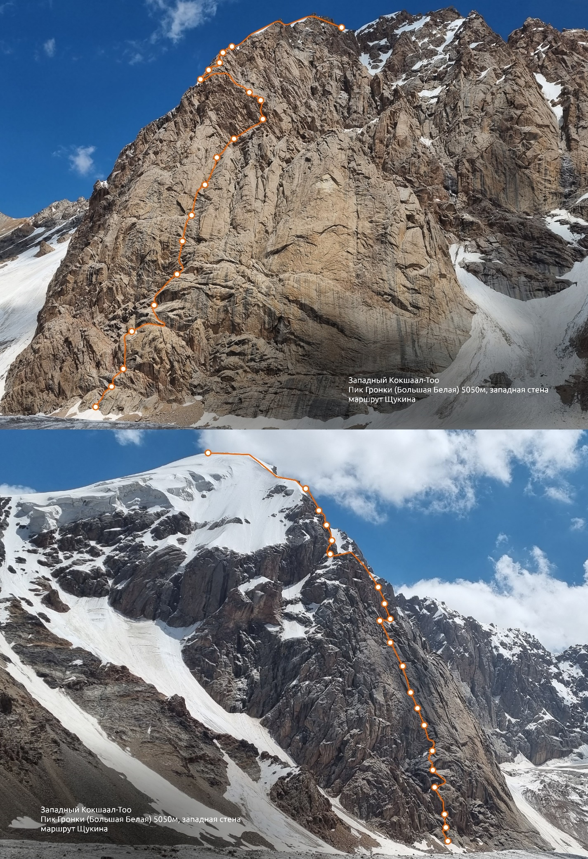
Panorama of the area
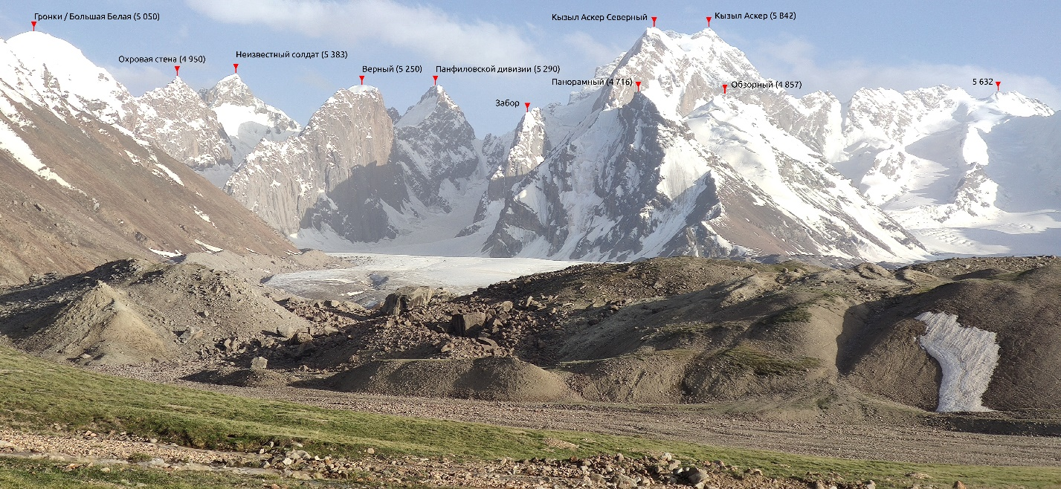

Map of the area
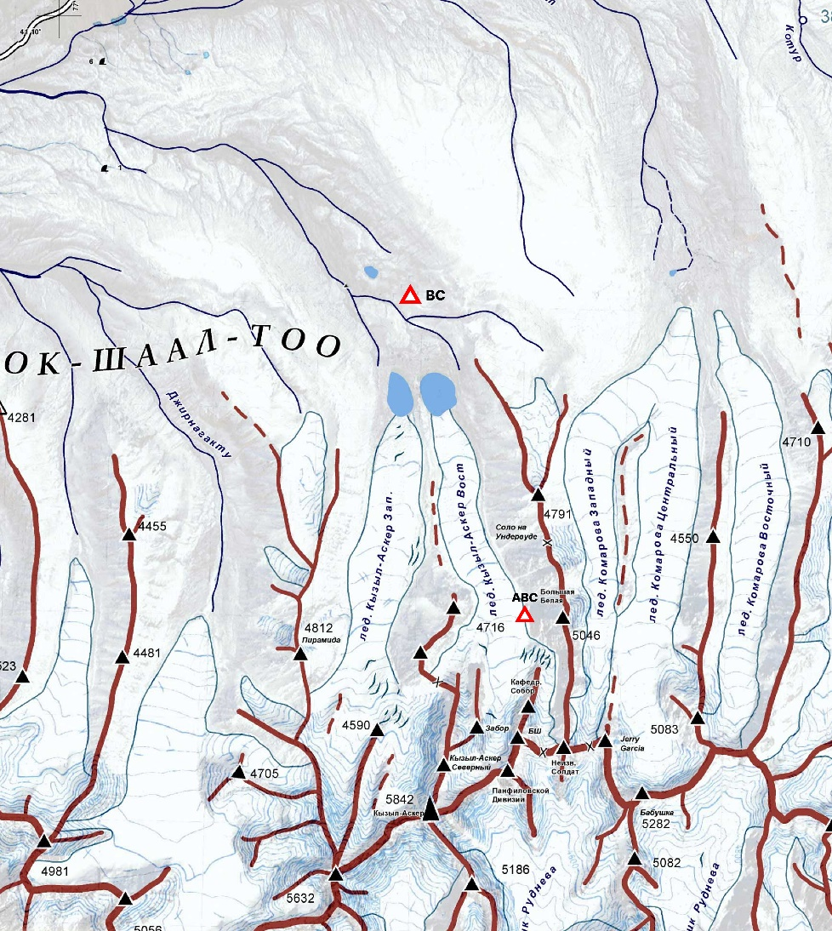

Description of the area
The area of the Kyzyl-Asker peak (5842m), Central Tien Shan, the Western Kokshaal-Too ridge , currently represents great potential for various first ascents . Due to complex logistics, this area was not popular among climbers for a long time. In recent years, the logistics situation has improved somewhat. It has become possible, albeit for quite a lot of money, to go straight to the base camp at the Kyzyl Asker East and West glaciers.
The region itself is rich in a large number of walls of different lengths and exposures, some of which have already become popular among climbers. For example, the south-eastern wall of Kyzyl-Asker and the western wall of Verny. However, on the Kyrgyz side, the region still has very interesting walls for a large number of potential first ascents . For example, the north-western wall of the Kyzyl-Asker and Kyzyl Asker North peaks with differences of 1-1.5 km and a length of about 2.5 km, on which at the moment there is only one route of the K. Valiev team (6A, 1985). Or the eastern wall of Zabor peak with a difference of about 800 meters and a relief more suitable for free climbing than on other walls. There are also many different ice rivers and couloirs for fans of mixed climbing. On the Chinese side, there are many walls of southern and south-eastern exposure.
When planning an expedition, it is recommended to study English-language resources, such as American Alpine Journal . The area is popular with foreign climbers.
The rock in the area is mainly granite with a small amount of microrelief and long (100m-1km) vertical cracks. Due to constant winds and the process of melting and freezing of water in the cracks, the rock in them is constantly destroyed, their edges can be crumbly. But for the most part, the rock is monolithic and the chances of turning something alive on yourself are quite low. Strong winds also form bizarre shapes from the rock in the windward areas.
The approaches to the routes are mostly long, without large differences in elevation. You have to walk a lot on closed glaciers with a lot of snow. Snowshoes make it easier to pass the glaciers. Although there are few cracks on the flat sections of the glaciers, there are many glacial rivers, some of which are serious obstacles. In warm weather, extremely unpleasant swamps appear on the glaciers for passing, usually these are deepened sections of the glacier, where a lot of snow accumulates 1-1.2 meters and up to half a meter of water accumulates under this snow.
The weather in the area is typical for the entire Tien Shan. Frequent precipitation, strong winds and sudden changes to sunny weather, which contributes to the constant formation of drip ice on the routes. Due to this, the area usually has good conditions for passing mixed lines. However, there are also periods of warm sunny weather. At this time, you should be careful with the choice of routes, since most of the drip ice in the area melts to zero in about a week of warm weather, exposing live rocks on the shelves and in the inner corners. Icefalls also become active and the avalanche danger of the area increases.
Temperatures can range from +20 on the southern walls on a sunny day or +5 on the northern ones to -20 at night. We are talking about temperatures at altitudes of 5000-5500 m. In the base camp, conditions are quite comfortable, +15 in the shade during the day and -2 at night in good weather. Precipitation even in the base camp is almost always in the form of snow. During a month of being in the area, it rained once.
The weather in the area is very windy and this should be taken into account when setting up a base camp.
As a result, the area has great potential for first ascents and requires a serious approach to expedition planning.

Characteristics of the ascent object
Peak Gronki , also known as Bolshaya Belaya in different sources (5040-5080 m according to different sources) is a pronounced snow dome with granite walls from the east and west. The rock is granite with predominantly vertical cracks. There are several documented ascents to this peak:
1 ) Along the northern ridge as part of the Bagger-Gronki traverse by the group of Dmitry Grigoriev, Dmitry Golovchenko and Sergey Nilov in 2014. Route category - 3B.
2) Along the eastern wall - A Bang for the Buck (350m, 6b+ WI5 M6) , Alex Blue , Maximilian Reiss , 2017.
3) Along the eastern buttress ( 800m, UIAA IV+ M5 75° ), Manuel Steiger , Alex Blue , Lisi Steurer , 2017.
4) Also during the ascent we came across old descent loops and a platform for a tent 60 meters to the right of our route. The platform was at the level of the 8th rope of our route. Along the line of the descent loops there was also a relief suitable for passing. However, we did not come across any traces of human presence above. We assume that this was someone's unsuccessful attempt. Unfortunately, we were unable to find any information about this ascent.

Features of the selected route line
We had a few days left before departure and the main criterion for choosing the route was the fastest possible passage. But at the same time we wanted the route not to be too easy. We chose the western wall of Gronki Peak , as it was not very long and steep. The difference in the wall part is about 600 meters and the average angle of 60-70 degrees allowed us to count on passing it within one day. However, despite the fact that the wall "lies", most of the climbing was from 5b ( fr ) and higher. This is due to the rock - monolithic granite with vertical smoothed cracks without holds. Also, the presence of an easy descent along the northern snow ridge and further along the scree from the pass to the glacier was a plus.

Team Tactics
On July 25th we approached the wall and chose the line of the wall section. On this day, Grigory Shchukin and Roman Shesternin processed 4 sections to increase the chances of completing the entire route the next day. Leonid Krupa was organizing the camp. This turned out to be the right decision later, as the terrain turned out to be more difficult than initially expected, which was good news.
On July 26th at 6 am we started working on the route. At about 6:20 pm we passed the wall part and reached the ridge. At 8:30 pm we were standing on the summit. At 10:30 pm we went down to the tent.
We did not take bivouac gear on the route, so we tried to work as quickly as possible. In order not to slow down on difficult sections in an attempt to pass them by free climbing, the leader immediately switched to aid climbing.
Theoretically, almost the entire route, except for the 2nd, 5th and 18th ropes, can be free climbed at the level of trad climbing in onsight 7a/b. The 2nd, 5th and 18th ropes can also be climbed, but you need to wait for the condition when water will not flow through the cracks and have a much more serious climbing level. Some of the cracks on the route were clogged with stones and sand, which also affected the speed of passing.
The first on both days was Shchukin Grigory, since he was the most rested member of the team and was interested in passing the route as the leader. The second and third participants went on jumars with top belay. The second participant on the day of the ascent was Leonid Krupa, the third - Roman Shesternin. Leonid Krupa was the first on the descent.

UIAA 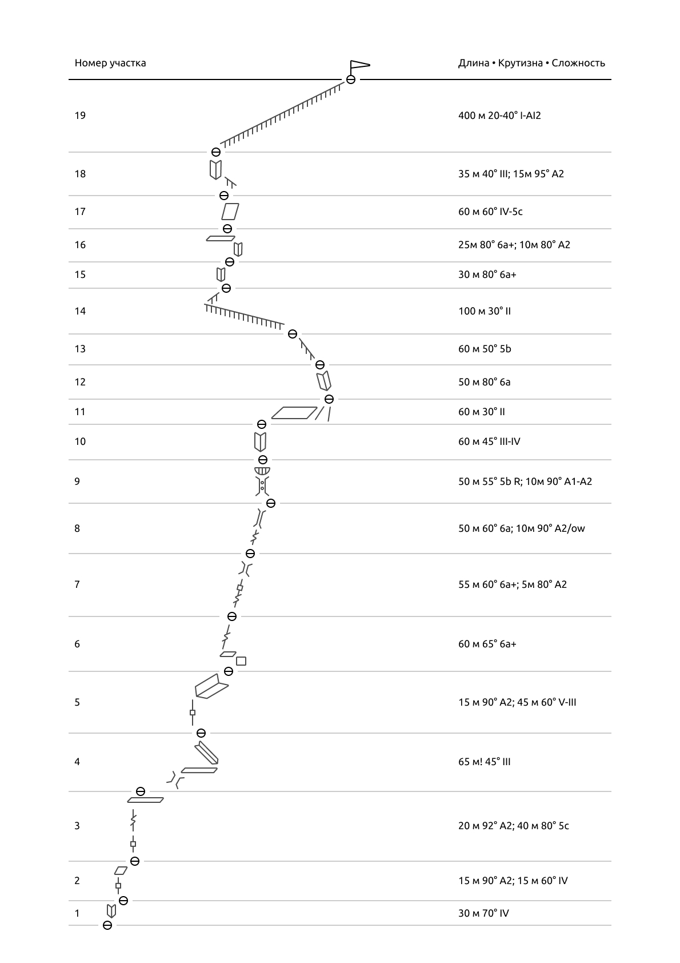symbols
Description of the route by sections
R 1 - A simple internal corner leads to an oblique shelf. The station is to the right of a clearly visible crack in the monolith.
R 2 - Along the crack on the ITO and further along the slab to the shelf. The station is also to the right of the crack.
R 3 - First, free climb for a few meters along the crack and then use aid climbing until it becomes possible to switch back to climbing, as the crack lies and leads to a scree ledge, on the left there is a convenient place for a station.
R 4 — To the right along the ledge, the ledge turns into a chimney, and then back into a ledge. We go along the ledge for 15-20 meters until we see a corner going to the left. If we put a dot in the corner, the rope will not be long enough to reach the ledge because of the zigzag. But the corner is simple, you can easily pass without belay.
R 5 — An overhanging crack under anchors and small friends, AID. As it lies, climb to a large oblique ledge/inner corner, up it the entire rope. Be careful, there are a lot of live rocks. The station is under a pronounced system of cracks.
R 6- R 8 — Up along a pronounced crack. The crack overhangs in places, in places it turns into chimneys or offvidzy , in places it is wet. Stations are on convenient ledges. We climb and do not turn anywhere.
R 9 — Up the couloir and then along the wet chimney. (There is a desire to go to the right before the chimney along a simple relief. But it soon turns into a bare monolith, there was a need to leave a hook with a loop for returning to the chimney) The chimney lies and there are many large plugs in it, some of them lie freely on top of each other like a house of cards, extremely careful climbing. The exit from the chimney is locked with a cornice plug. Climbing along the right side, a neat climb out onto the scree, then a few meters along the scree and a convenient station in the middle of the corner.
R 10 - Along simple angles up to the sloping shelf under the overhang.
R 11 - Simple crossbar along the shelf under the base of the inner corner.
R 12 — A small wall and a traverse to the left into a corner consisting of huge living blocks. It looks unreliable, but in fact everything climbs fine . The corner leads to a ridge, 5 meters along the ridge and a convenient station. (This rope can be climbed straight up a monolithic overhanging crack on AID if you don't want to climb into the corner)
R 13 - First to the right of the ridge, then along the corner to the ridge. Then a steep ridge. The large block is bypassed on the left. The station is convenient.
R 14 — In a bundle to the right of the ridge to the snow ridge. A cornice hangs from the ridge to the north. From the ridge to the right, up under the inner corner.
R 15 — Along the wall-shelves under the inner corner with smooth walls and a crack. Camalots 2-3 work up to the middle of the corner. Then the crack widens to sizes 4-5. We didn’t have them, we had to climb 7-8 meters without safety equipment in a drop-off . If you fall, there is a chance of landing on the shelf at an angle. (Recommendation for future climbers: take Camalot 4 if you are not sure that you can climb this comfortably) The station is on a convenient shelf under the cornice. Here, if desired, you can organize a comfortable overnight stay.
R 16 — From the station, first go up into the grotto, and from there to the right around the corner along the crack, around the corner the crack dies out, there you need to gather yourself and crawl along the monolithic wet wall to the right up to another crack, along it on ATO to the shelf. Along the shelf to the left and go down a little to a larger shelf, on it there is a convenient station.
R 17 - To the left of the station, along the lying slabs with cracks, there will be a small overhanging step, then a small fireplace and a station on a ledge in front of the ice slope.
R 18 — We climb the ice slope along the rocky ridge on the right and then go left to the base of the overhanging corner. At first the corner is climbed by free climbing, but after a small ledge it twists and forks. We climb into the left overhanging corner along the cornice, inconvenient AID under the cornice, but the belay is reliable. Then through the cornice to the ridge and along it to a convenient place for the station. The section is inconvenient for the last participant, because it is inconvenient to take out the points from under the cornice. (If you have camalots of size 4-5, you can go along the right corner, it also overhangs, but for the other participants it may be easier there, because it goes vertically upwards)
R 18 — Along the ridge in a rope to the summit. At first the ridge is steep and icy, you have to belay with screws and gather to pass the screws to the leader. Closer to the summit the ridge flattens out , snow and cracks appear. The summit is a sharp ridge extending south from the snow cap.

Descent
Descent to the north along an indistinct wide ridge. The ridge is steep and heavily loaded with snow. At the beginning, it is recommended to send one participant with insurance to check the snow condition. We were lucky, because it was a cloudy day, the snow was not soggy and it was possible to descend relatively safely. Otherwise, we would have had to spend the night under the summit and descend early in the morning. Then the ridge flattens out and you need to follow it to the beginning of the ascent to Yurnos Peak . From there, down the scree towards the Kyzyl-Asker East Glacier. If you turn off earlier, you can end up on ice or faults.

General recommendations for climbers
Spend a day under the wall and see how it behaves. There was a rockfall the night after our ascent, which also affected part of the route we had taken. All the shelves on the wall are smoothed and there are a lot of stones on them, be careful not to drop anything when climbing onto the shelves and watch how the rope is laid.
The descent after a snowfall will be dangerous due to avalanches.
Theoretically, it is possible to descend along the more pronounced northwestern ridge towards the Komarov glacier. The ridge will run into a buttress, where you will most likely have to organize a descent along an ice couloir. You will have to return through another gorge. If you descend like this, go on reconnaissance. And rotate the mountain in Google Earth , everything is clear there.

Equipment Used
Standard set of double 0.5-3 camalots , set of chocks, 10 anchors and several U -shaped channels. Also hooks , ladders and two fifi with a bend. 3 dynamic ropes.
All chocks and hooks worked well on the route. In a couple of places I wanted 4-5 camalots , but you can live without them.
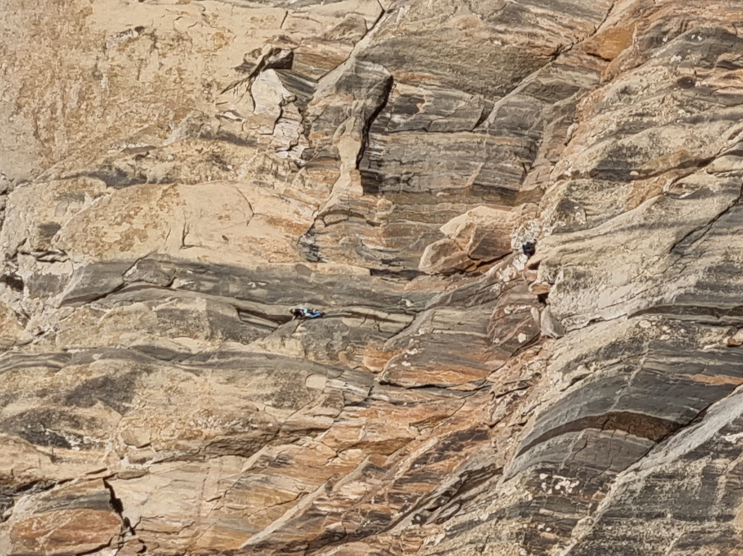
Plot R 3 .
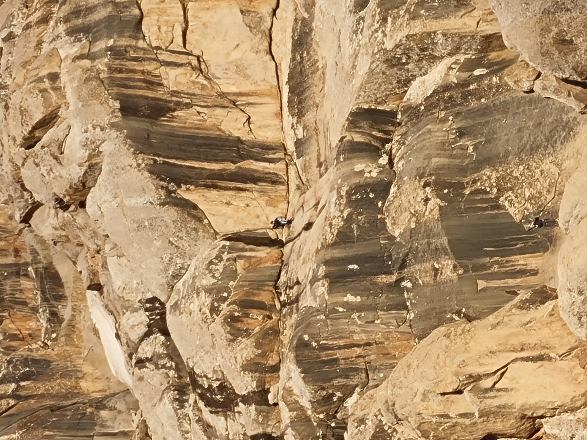
The leader assembles the station after passing section R 4. Section R 5 is visible above .
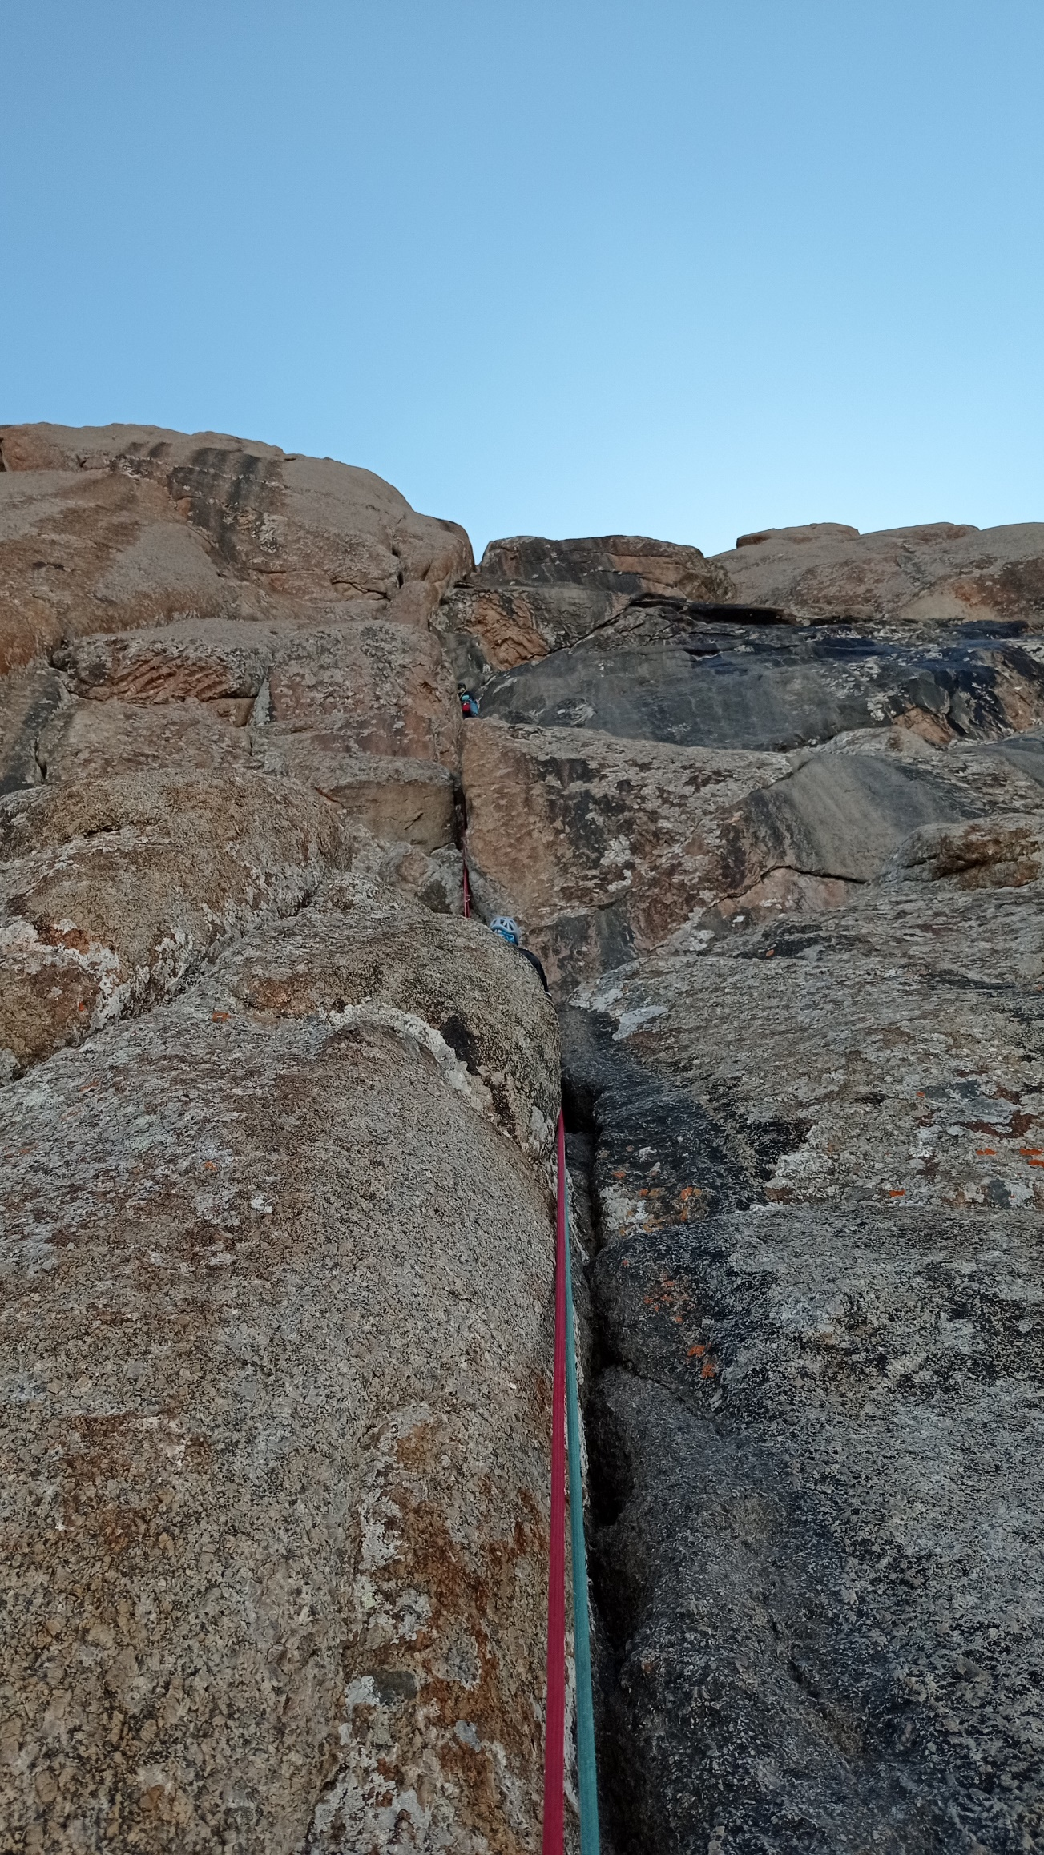
The end of section R 7 and section R 8.
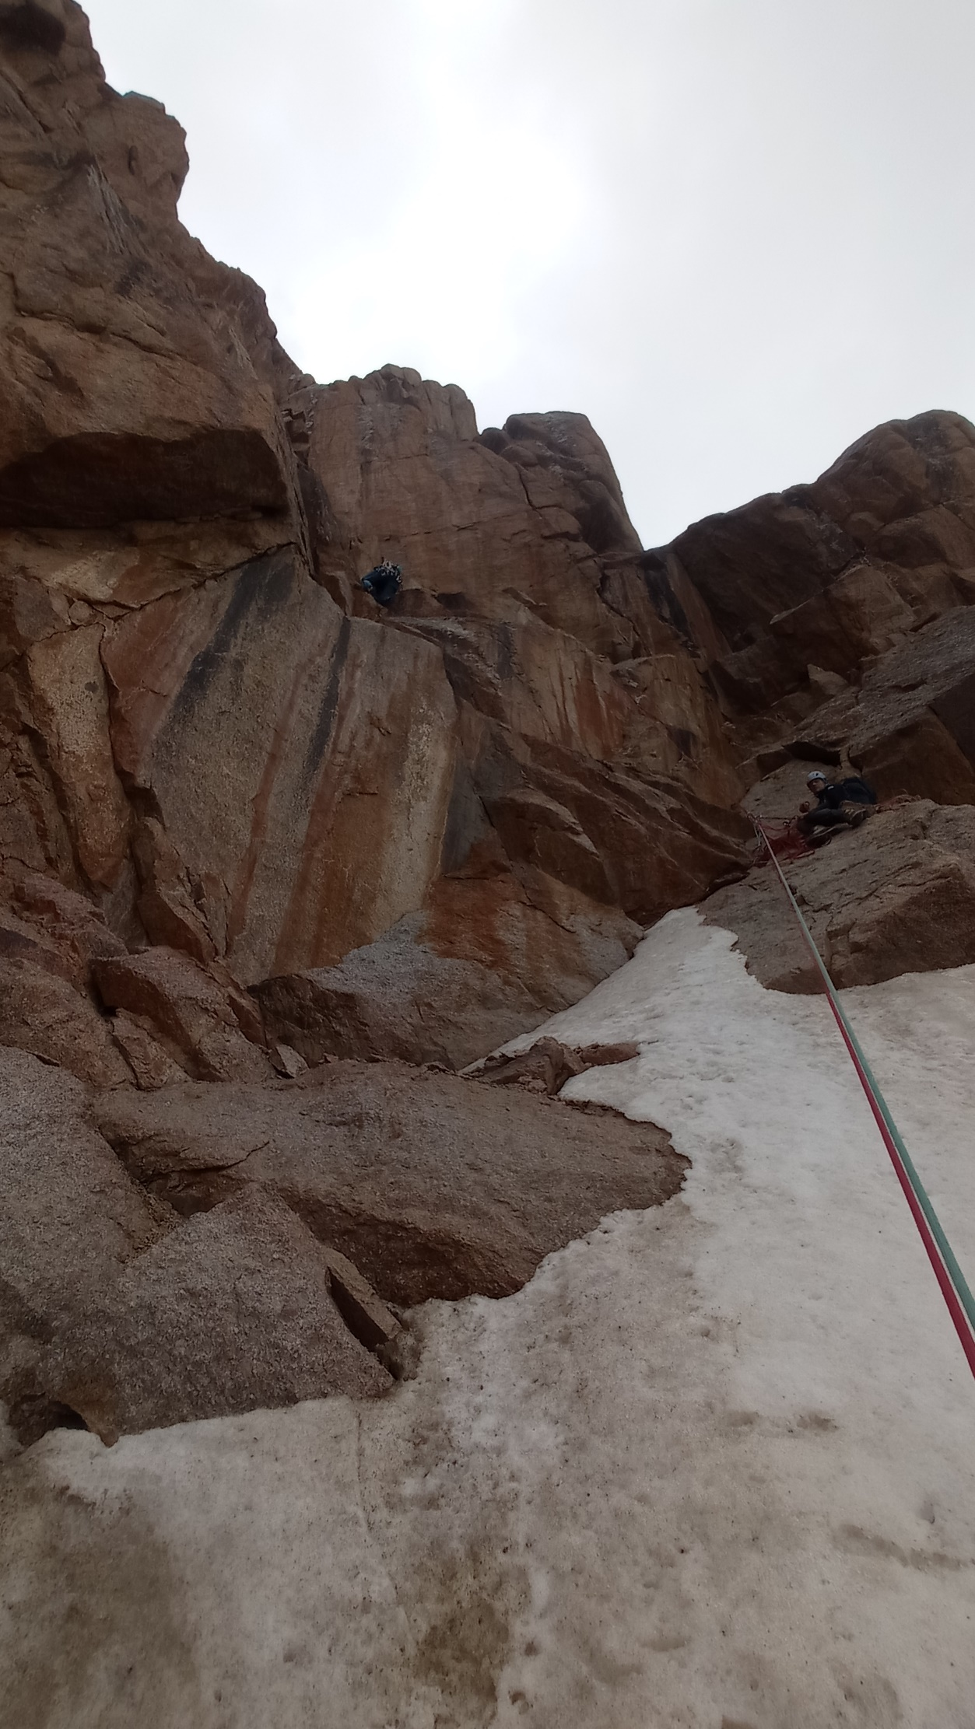
The end of section R 11 and section R 12.
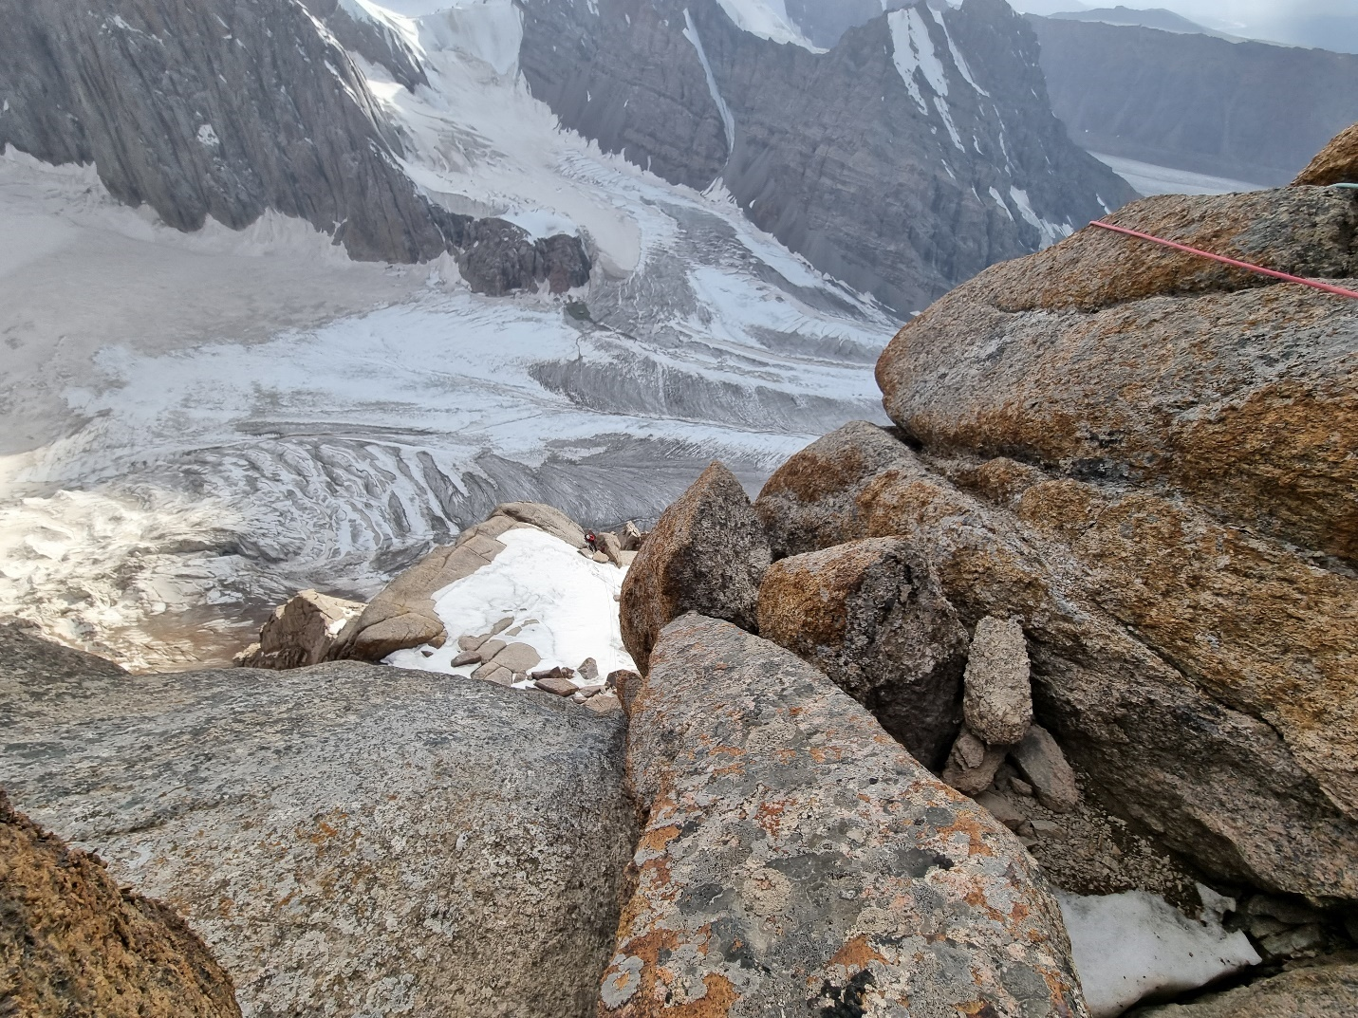
Beginning of section R 18. Photographed from the station of section R 18.

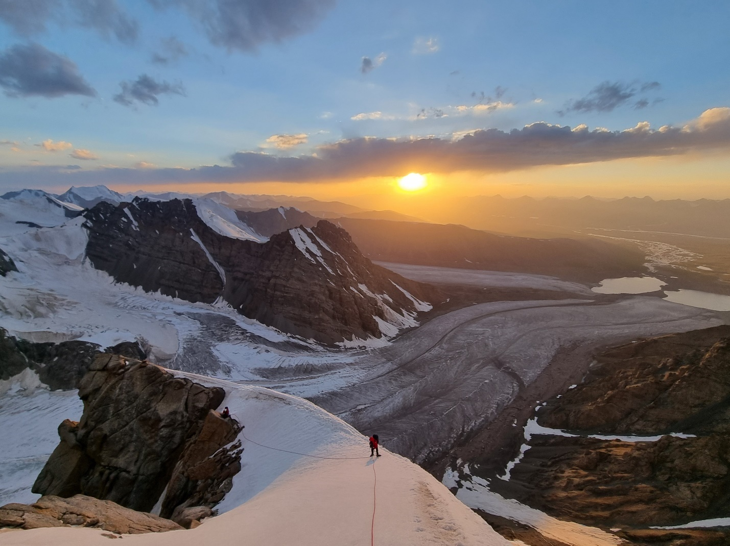
Somewhere in the middle of the R 19 section. The summit ridge.

